# Video Library

Review the full library of videos here:   
[**https://info.businessolver.com/video-library-resources-1**](https://info.businessolver.com/video-library-resources-1)

To embed on your layout, follow these instructions:

1. Drag a Text Widget onto the layout.
2. In the text widget, select the Source Code option in the editor
3. **A screenshot of a computer

   Description automatically generated**Copy and paste the below embed code for the video you want placed there. Hit save twice.

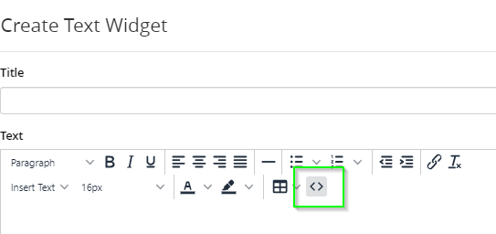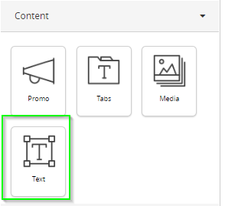

Video Library 1

MyChoice Accounts Embed Codes 2

Voluntary Benefits Videos 4

General Benefitsolver Videos 6

# MyChoice Accounts Videos

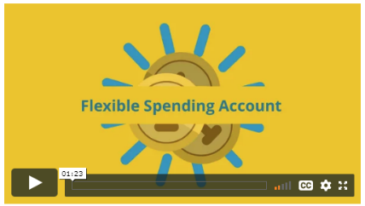**What is an FSA?**

*Copy and paste the below code:*

<!-- 16:9 aspect ratio -->

<div class="embed-responsive embed-responsive-16by9"><iframe class="embed-responsive-item" src="https://player.vimeo.com/video/455910435" width="640" height="360" frameborder="0"></iframe></div>

**What to Consider for an FSA**

*Copy and paste the below code:*

<!-- 16:9 aspect ratio -->

<div class="embed-responsive embed-responsive-16by9"><iframe class="embed-responsive-item" src="https://player.vimeo.com/video/456731130" width="640" height="360" frameborder="0"></iframe></div>

**What is an HRA?**

*Copy and paste the below code:*

<!-- 16:9 aspect ratio -->

<div class="embed-responsive embed-responsive-16by9"><iframe class="embed-responsive-item" src="https://player.vimeo.com/video/461993819" width="640" height="360" frameborder="0"></iframe></div>

**What is an HSA?**

*Copy and paste the below code:*

<!-- 16:9 aspect ratio -->

<div class="embed-responsive embed-responsive-16by9"><iframe class="embed-responsive-item" src="https://player.vimeo.com/video/462397664" width="640" height="360" frameborder="0"></iframe></div>

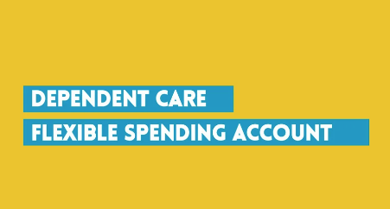**What is an DCFSA?**

*Copy and paste the below code:*

<!-- 16:9 aspect ratio -->

<div class="embed-responsive embed-responsive-16by9"><iframe class="embed-responsive-item" src="https://player.vimeo.com/video/463053043" width="640" height="360" frameborder="0"></iframe></div>

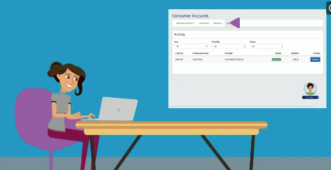**MyChoice Accounts Managing Your Account**

*Copy and paste the below code:*

<!-- 16:9 aspect ratio -->

<div class="embed-responsive embed-responsive-16by9"><iframe class="embed-responsive-item" src="https://player.vimeo.com/video/461994152" width="640" height="360" frameborder="0"></iframe></div>

**MyChoice Accounts: Accessing Your Funds**

*Copy and paste the below code:*

<!-- 16:9 aspect ratio -->

<div class="embed-responsive embed-responsive-16by9"><iframe class="embed-responsive-item" src="https://player.vimeo.com/video/461994495" width="640" height="360" frameborder="0"></iframe></div>

****Swipe and Save with your FSA**

*Copy and paste the below code:*

<!-- 16:9 aspect ratio -->

<div class="embed-responsive embed-responsive-16by9"><iframe class="embed-responsive-item" src="https://player.vimeo.com/video/ 592860780" width="640" height="360" frameborder="0"></iframe></div>

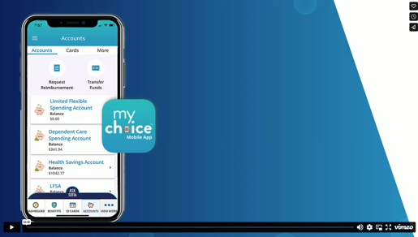**MyChoice Accounts: Member Mobile App Demo**

*Copy and paste the below code:*

<!-- 16:9 aspect ratio -->

<div class="embed-responsive embed-responsive-16by9"><iframe class="embed-responsive-item" src="https://player.vimeo.com/video/846017323" width="640" height="360" frameborder="0"></iframe></div>

# Voluntary Benefits Videos

 **Accident insurance**

*Copy and paste the below code:*

 <!-- 16:9 aspect ratio -->

<div class="embed-responsive embed-responsive-16by9"><iframe class="embed-responsive-item" src=<https://player.vimeo.com/video/460397509> width="640" height="360" frameborder="0"></iframe></div>

**Hospital Indemnity**

*Copy and paste the below code:*

<!-- 16:9 aspect ratio -->

<div class="embed-responsive embed-responsive-16by9"><iframe class="embed-responsive-item" src=<https://player.vimeo.com/video/461124877> width="640" height="360" frameborder="0"></iframe></div>

**Critical Illness**

*Copy and paste the below code:*

 <!-- 16:9 aspect ratio -->

<div class="embed-responsive embed-responsive-16by9"><iframe class="embed-responsive-item" src=<https://player.vimeo.com/video/461066479> width="640" height="360" frameborder="0"></iframe></div>

**ID Theft**

*Copy and paste the below code:*

<!-- 16:9 aspect ratio -->

<div class="embed-responsive embed-responsive-16by9"><iframe class="embed-responsive-item" src=<https://player.vimeo.com/video/460610867> width="640" height="360" frameborder="0"></iframe></div>

**EAP**

*Copy and paste the below code:*

<!-- 16:9 aspect ratio -->

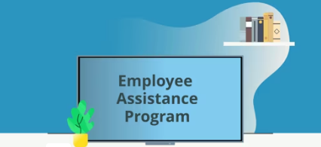<div class="embed-responsive embed-responsive-16by9"><iframe class="hs-responsive-embed-iframe" style="position: absolute; top: 0; left: 0; width: 100%; height: 100%; border: none;" allow="autoplay; fullscreen" xml="lang" src="//player.vimeo.com/video/456267722?title=0&amp;byline=0&amp;portrait=0&amp;color=8dc7dc" width="900" height="506" frameborder="0" allowfullscreen="" data-service="vimeo"></iframe></div>

**Telemedicine**

*Copy and paste the below code:*

<!-- 16:9 aspect ratio -->

<div class="embed-responsive embed-responsive-16by9"><iframe class="hs-responsive-embed-iframe" style="position: absolute; top: 0; left: 0; width: 100%; height: 100%; border: none;" allow="autoplay; fullscreen" xml="lang" src="https://player.vimeo.com/video/460285266?badge=0&amp;autopause=0&amp;player_id=0&amp;app_id=58479" width="900" height="506" frameborder="0" allowfullscreen="" data-service="vimeo"></iframe></div>

**Legal**

*Copy and paste the below code:*

<div class="embed-responsive embed-responsive-16by9"><iframe class="hs-responsive-embed-iframe" style="position: absolute; top: 0; left: 0; width: 100%; height: 100%; border: none;" allow="autoplay; fullscreen" xml="lang" src="https://player.vimeo.com/video/461126014?badge=0&amp;autopause=0&amp;player_id=0&amp;app_id=58479" width="900" height="506" frameborder="0" allowfullscreen="" data-service="vimeo"></iframe></div><!-- 16:9 aspect ratio -->

# 

# General Benefitsolver Videos

**Sofia**

*Copy and paste the below code:*

<p>Available 24/7, Sofia&trade; is your virtual benefits assistant. Whether you need help understanding your medical plan or assistance navigating the site, you can always chat with her.</p>

<!-- 16:9 aspect ratio -->

<div class="embed-responsive embed-responsive-16by9"><iframe class="embed-responsive-item" src="https://player.vimeo.com/video/454522952" width="640" height="360" frameborder="0"></iframe></div>



**Decision Support (formerly “MyChoice Recommendation Engine”)**

*Copy and paste the below code:*

<p>Enroll using the decision support tool to get guidance when choosing the right benefits. Answer a few questions about your health and lifestyle, and you will receive a personalized recommendation.</p>

<!-- 16:9 aspect ratio -->

<div class="embed-responsive embed-responsive-16by9"><iframe class="embed-responsive-item" src="https://player.vimeo.com/video/452265325" width="640" height="360" frameborder="0"></iframe></div>

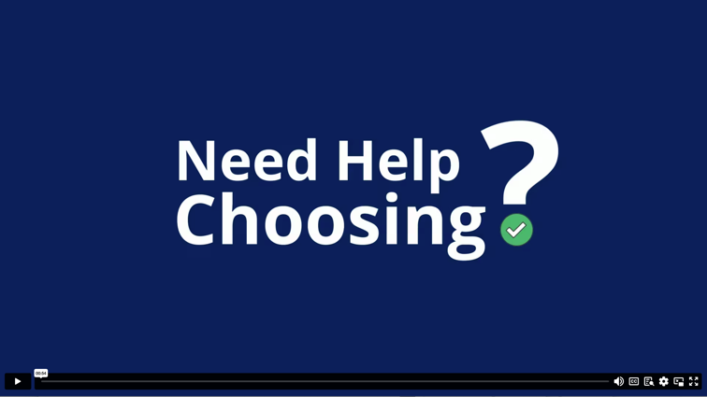

**MyChoice Mobile App – without MyChoice Accounts**

*Copy and paste the below code:*

<p>Manage your benefits on the go and access this site from any smartphone or tablet. You can store pictures of your ID cards, access coverage details, change your benefits and much more.</p>

<!-- 16:9 aspect ratio -->

<div class="embed-responsive embed-responsive-16by9"><iframe class="embed-responsive-item" src="https://player.vimeo.com/video/453420209?app_id=122963" width="640" height="360" frameborder="0"></iframe></div>

**MyChoice Mobile App – with MyChoice Accounts**

<p>Manage your benefits on the go and access this site from any smartphone or tablet. You can store pictures of your ID cards, access coverage details, change your benefits and much more.</p>

<!-- 16:9 aspect ratio -->

<div class="embed-responsive embed-responsive-16by9"><iframe class="embed-responsive-item" src="https://player.vimeo.com/video/910064483?h=e350e8fce3&amp;badge=0&amp;autopause=0&amp;player_id=0&amp;apa_id=58479" width="640" height="360" frameborder="0"></iframe></div>

