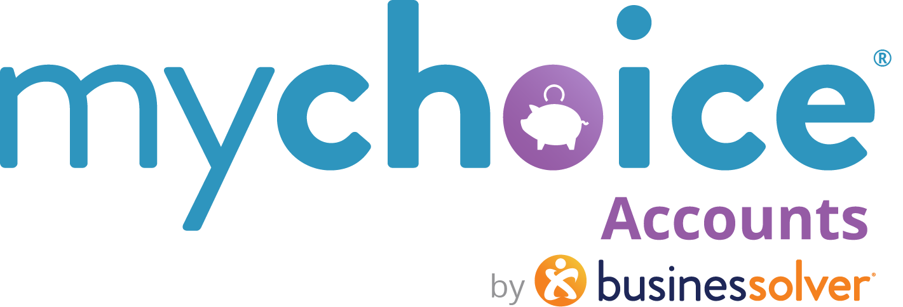

Dependent Care FSAs
Dependent Care Assistance Programs

How to use this document:
- If you need to populate a benefits guide, web page, or virtual benefits fair, feel free to pull the relevant copy from this guide.
- Items that are client-level/client-specific plan designs are marked in yellow. Ensure your client-specific information is updated in those fields.

Dependent Care FSAs

Already paying for dependent care?
If you pay for day care, after school care, day camp or elder care for any of your dependents, you could be SAVING money on those costs! How? So glad you asked. {Organization name} offers a dependent care flexible spending account, or DCFSA, that allows you to set aside a little from each paycheck to go toward your dependent care for the year.
How does this help? You never pay taxes on these funds, which saves you 20-30% over paying for care outright.
Why enroll? Setting aside your funds in a dependent care account can save you between $1,000 - $1,500 a year!*
*contributing the maximum allowed at $5,000 at a 20% – 30% tax savings.

Things to Know
- How much can I contribute each year?
$5,000 is the maximum amount, but you can contribute a smaller amount as needed. Remember that funds will come out of each paycheck and not all at once. Elect as much as needed to cover all your expected 2025 dependent care expenses.

- Use it up!
Be sure to USE those DCFSA funds every year during your plan period. Remember to consider expenses like summer day camp or child or dependent care used while you’re working. DCFSA funds can also be used for adult dependent day care.

How to use your funds

Dependent care funds are available as you make payroll contributions throughout the year.

CARDED ACCOUNTS
Use your MyChoice Accounts Visa debit card to pay qualified providers for care. Submit documentation for the dependent care expense via your online platform or the MyChoice Mobile App.

- Log into [[benefits URL]] and select MyChoice Accounts, or from the mobile app, select Accounts.
- Go to Claims and Claim Summary. On the claim that needs documentation, select the three-dot menu ••• and select Edit Claim. Add your documentation to the bottom of this claim, select Review, and Submit.
- If you don’t have your card handy, you may submit a claim for a reimbursement through {your Benefitsolver URL} or the MyChoice Mobile App.

NON-CARDED ACCOUNTS

You may submit a claim for a reimbursement through {your Benefitsolver URL} or the MyChoice Mobile App.
- Log into [[benefits URL]] and select MyChoice Accounts, or from the mobile app, select Accounts.
- Select Submit Claim and fill in details related to your reimbursement request.
- Attach documentation, Review, and Submit.
- You will be reimbursed for the available amount in your account. If your claim exceeds your available balance, we will pend the remainder of your claim and reimburse you on your next contribution.

Documentation
In order to comply with IRS rules, we will want to see the following information on your documentation:
- Name of dependent receiving care
- Amount paid for service
- Type of service (day care, day camp, after-school, elder care, etc.)
- Provider name and address
- Date(s) of service
- Provider signature (if submitting an ongoing reimbursement form)

Eligible Expenses

Eligible Dependent Care Expenses
- Licensed day care providers
- Qualifying care for dependent adults (elder care)
- Pre-school or nursery school
- Day camp (summer or holiday)
- Late-stay fees
- Private sitter
- Before school or after school care

Review a list of common eligible expenses // LEARN MORE
(Hyperlink: https://www.businessolver.com/mychoice-accounts/participants/dependent-care-fsa-eligible-expense)

