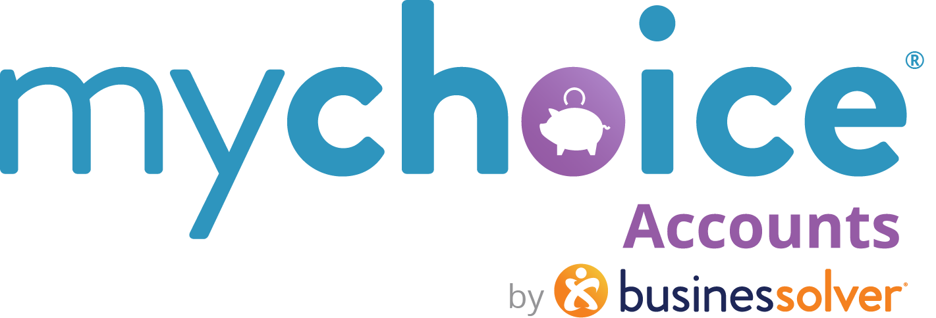

Limited Purpose Flexible Spending Accounts
LFSAs or LPFSAs
How to use this document:
- If you need to populate a benefits guide, web page, or virtual benefits fair, feel free to pull the relevant copy from this guide.
- Items that are client-level/client-specific plan designs are marked in yellow. Ensure your client-specific information is updated in those fields.

Limited Purpose FSAs or Limited FSAs
How an FSA can benefit you and your wallet
If you are new to the flexible spending account (FSA), or if you’ve been processing those receipts for years, here are some key details to help you make the most of your Limited Purpose FSA.

Earmarked for Teeth and Eyes
A limited purpose flexible spending account, or LPFSA, is a special type of FSA. It’s an employer-sponsored benefit that allows participants to set aside pre-tax funds from their paychecks to help them pay for out-of-pocket dental and vision expenses throughout the year.
FSAs are an annual plan-year benefit—meaning you have a specified amount of time to use your funds. You'll want to spend down this account every year based on your plan's rules.
Why enroll? Paying for your out-of-pocket costs for your dental and vision expenses allows you to preserve your HSA or HRA balance and to participate in a high deductible health plan with lower monthly premiums.
Am I eligible for a limited purpose FSA?
If you are enrolled in a health savings account (HSA), the type of FSA you can enroll in is the limited purpose FSA, due to IRS regulations. You can’t hold both a standard health care FSA and an HSA at the same time. If you have ongoing dental, orthodontic, or vision expenses, the LPFSA helps you preserve your HSA funds to save for the long term.

Things to Know
- How much can I contribute each year?
- $3,200 for individual in 2025
- (Please review the note on this FSA limit >>)

- Carry over Provision ((OR))
Grace Period
Use either option one or option two, depending on your plan design:

(OPTION ONE): Carry Over Provision  Rest easy. If you don’t spend 100% of your funds during the calendar year, you can take some money with you into 2025. Your plan has a carry over provision, meaning we will be transfer your remaining balance up to {amount – standard allowable is $640} into your 2026 FSA. | (OPTION TWO): Grace Period  Use it or lose it? Yes. Your plan comes equipped with a grace period to help you spend your FSA completely and not lose any funds. You have until March 15, 2026, to use your 2025 elections. Make sure you submit all claims by March 31, 2026.

- SPEND, SPEND, SPEND
Be sure to USE those FSA funds every year during your plan period. Your deadline for submitting claims for 2025 is {insert claims deadline date}.

Eligible Expenses
Review a list of common eligible expenses // LEARN MORE

learn more hyperlink:
https://www.businessolver.com/mychoice-accounts/participants/limited-purpose-eligible-expense

