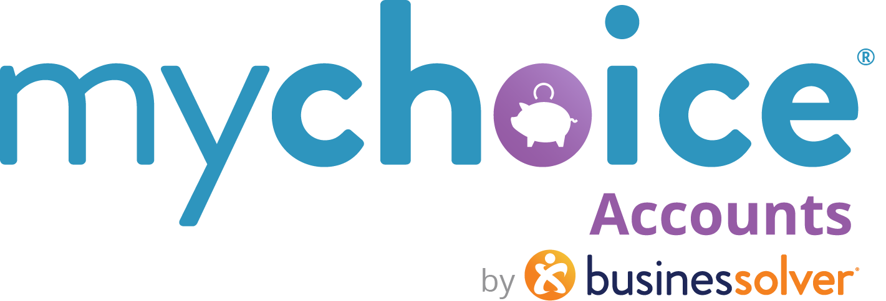

Commuter Benefits
Transit and/or Parking

How to use this document:
- If you need to populate a benefits guide, web page, or virtual benefits fair, feel free to pull the relevant copy from this guide.
- Items that are client-level/client-specific plan designs are marked in yellow. Ensure your client-specific information is updated in those fields.
Commuter Benefits

For employers who are offering parking or transit benefits

On the Road Again?
Commuter Benefits can help you stretch your paycheck. If you take a form of mass transit to work or pay for parking for work, you could be getting some money back into your wallet. The IRS says you can set aside funds for transit and/or parking without ever paying taxes on that money, so your savings month over month can really add up!
Why enroll? Take advantage of tax savings for something you may already do. You can make changes to your commuter election if needed during the year, so you’re not locked in to an amount.
Commuter TRAIN-ing
- How much can I contribute?
The IRS determines a monthly amount in each type of accounts. For 2025, you can set aside up to $315/month for parking and up to $315/month for transit.

- What if I skip a month or two?
Your commuter benefits do not expire and roll over year over year; however, if you know you will be skipping a FEW months, you should change or pause your election amount during the year. Funds stay with your employer if you depart from your organization. These benefits are meant to be used monthly to optimize the savings.

- What do my commuter benefits cover?
Your transit funds may be used to purchase fare for bus, subway, train, trolley, ferry and light rail as well as verified carpooling programs, such as a metro vanpool and ridesharing programs like UberPool and Lyft Shared (not for single-rider services from those or similar companies).
Parking funds may be used to pay for work-related parking expenses, such as parking garages/lots, meters and parking expenses incurred near a transit station.

- Can I get reimbursed for my subway or transit fare?
No. The IRS does not allow for transit reimbursements. They required a “readily available” payment method. Use your MyChoice Accounts debit card (if you have another account, like an FSA or HSA—it’s the same card) to purchase your fare or pay for ride-sharing services. For best results, purchase on the transit provider app or at a designated kiosk. Any locations that sell fare in addition to other goods may not be recognized by your card. (i.e. a drugstore that also sells transit tickets)

Bookmark This
If you have questions throughout the year about your Commuter Benefits, check out these online resources // LEARN MORE
(learn more link to: https://www.businessolver.com/mychoice-accounts/participants/commuter-benefits)

SUBSIDY ALTERNATE TEXT
If your company offers a SUBSIDY to help members, update the copy to include your subsidy amount for item #1 above.

- How much can I contribute?
The IRS determines a monthly amount in each type of accounts. For 2025, you can set aside up to $315/month for parking and up to $315/month for transit. Your employer offers a ${###}/month subsidy to help you offset your costs, so you will be able to contribute up to the additional ${###}/month.

