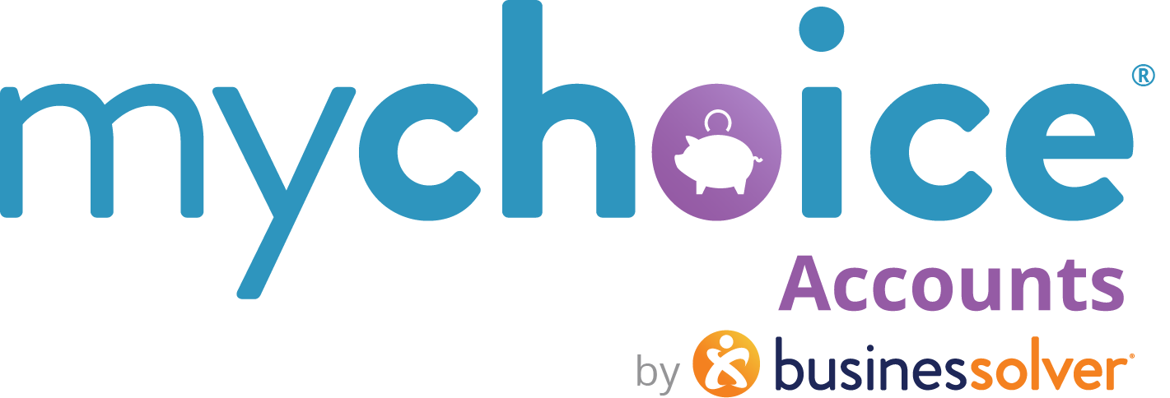

Health Reimbursement Accounts (or arrangements)
HRAs

How to use this document:
- If you need to populate a benefits guide, web page, or virtual benefits fair, feel free to pull the relevant copy from this guide.
- Items that are client-level/client-specific plan designs are marked in yellow. Ensure your client-specific information is updated in those fields.

HRAs vary significantly by employer. Please adjust the template copy as needed to reflect the eligible expenses your company has determined.
Medical HRAs

What is an HRA?
Your HRA is sponsored by {insert company name}. It is an account set up to help you cover health care related expenses.
You have ${XXXX} per year to use for out-of-pocket medical expenses. Here are some of the items and services you can pay for with your HRA:
- Provider office visits – dental, vision, medical, labs, hospitals
- Prescription medications
- Over the counter remedies (medications, some equipment)
- Feminine hygiene products
- First aid items – bandages, alcohol, antibiotic cream, etc.
- Glasses, contacts, most dental work, orthodontic care
Where can I use my HRA?
Review a list of common eligible expenses
(Hyperlink: https://www.businessolver.com/mychoice-accounts/participants/fsa-hra-eligible-expense)

(for carded HRA accounts)
How do I access my HRA funds?
- Use your MyChoice Accounts Visa debit card at your provider, lab, hospital, or retailer or use it to pay your eligible medical bills.
- If you don’t have your card handy, you may submit a claim for a reimbursement through {your Benefitsolver URL} or the MyChoice Mobile App.
(for non-carded HRA accounts)
How do I access my HRA funds?
Use your out-of-pocket funds for any eligible expense, and easily create a claim for reimbursement.
For faster reimbursements, go to Manage and Bank accounts and add your banking information into our secure portal, and we will send your reimbursements directly into your account.

- Log in to your benefits website at {URL} or into your MyChoice Mobile App. Select MyChoice Accounts online or Accounts in the mobile app.
- Select Claims and Submit Claim and fill in the required fields.
- Provide documentation of your expense, ensuring that you include the following information:
  - Name of purchaser/recipient of service
  - Date of purchase/service
  - Name of item or service
  - Retailer or provider name
  - Amount paid for purchase/service
- Follow the directions in the claim interface to upload the documentation to Review Claim, then review and select Submit Claim.
- You will receive your reimbursement within 5-10 business days if you have submitted everything required or faster if you have set up direct deposit by adding a bank account to your HRA.
Bookmark This
If you have questions throughout the year about your HRA, check out these online resources // LEARN MORE
(learn more hyperlink: https://www.businessolver.com/mychoice-accounts/participants/health-reimbursement-arrangement)
Save time and money with the HRA Store!
If you need to stock up your family first aid cabinet, get some over-the-counter items like medicine, insoles, baby monitors, and more…check out the HRA Store. Everything there is 100% verified and an HRA-eligible item…and 99% of the time, there are no additional receipts needed.
Here’s a coupon code for $5 off. Use code 5OFFBSC at checkout.
URL: https://tpa.fsastore.com/hra-store.html?a_aid=5bf468aa5c776&utm_source%252BBusinessolver=&utm_medium=TPA+Link+HRA&utm_campaign=TPA+Partner

